Avian Situation Report for John Day and The Dalles Dams 8/10/11
Last reporting for the 2011 outmigration season
Fish Field Unit
Foraging gull numbers remain low, at both projects though at times spiked (as did fish consumption) especially at The Dalles Dam. In particular on July 21 The Dalles hazing boat was in for maintenance as gulls and fish consumption peaked, but then dropped the following day when the boat was present (Figure 1). However we did not record a concurrent increase of birds at John Day that same day when that boat was out for maintenance also. Currently gull numbers are low at this time with less than 3 actively foraging birds working either project.
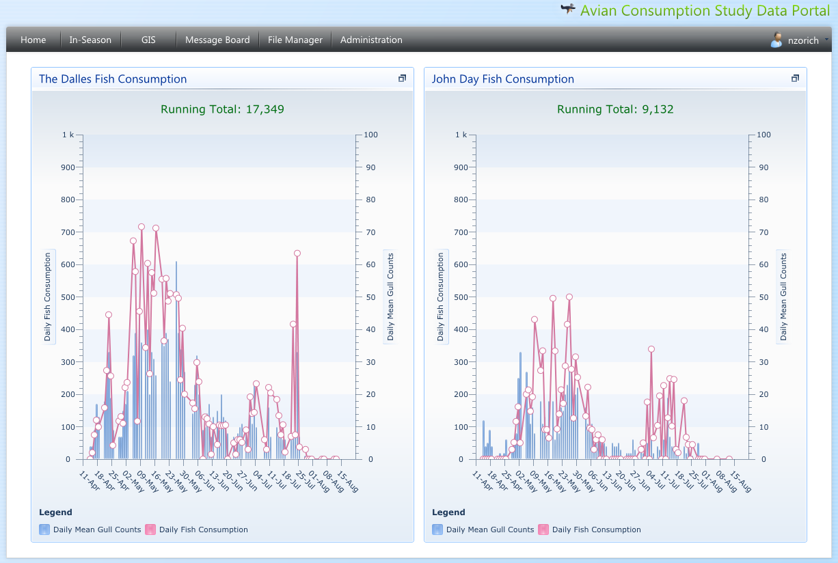
Figure 2. Mean daily gull counts (bars) and expanded daily fish consumption (circles). Running Total value is a point estimate and subject to change as data is proofed and will increase when expansion is used to cover weekends. Fish other than smolt ( i.e. lamprey macropthalmia) are also being consumed.

Gull attack locations at John Day Dam (Figure 3) were focused downstream of the avian deterrent lines as they were in 2010. Occasionally, gulls did penetrate the lines by hovering above them then penetrate the lines stopping a few feet above the water and attacking from there. Still that happened so infrequently that is does not show up on the heat map, out weighted by the hot spots, but will be quantified for the annual report.

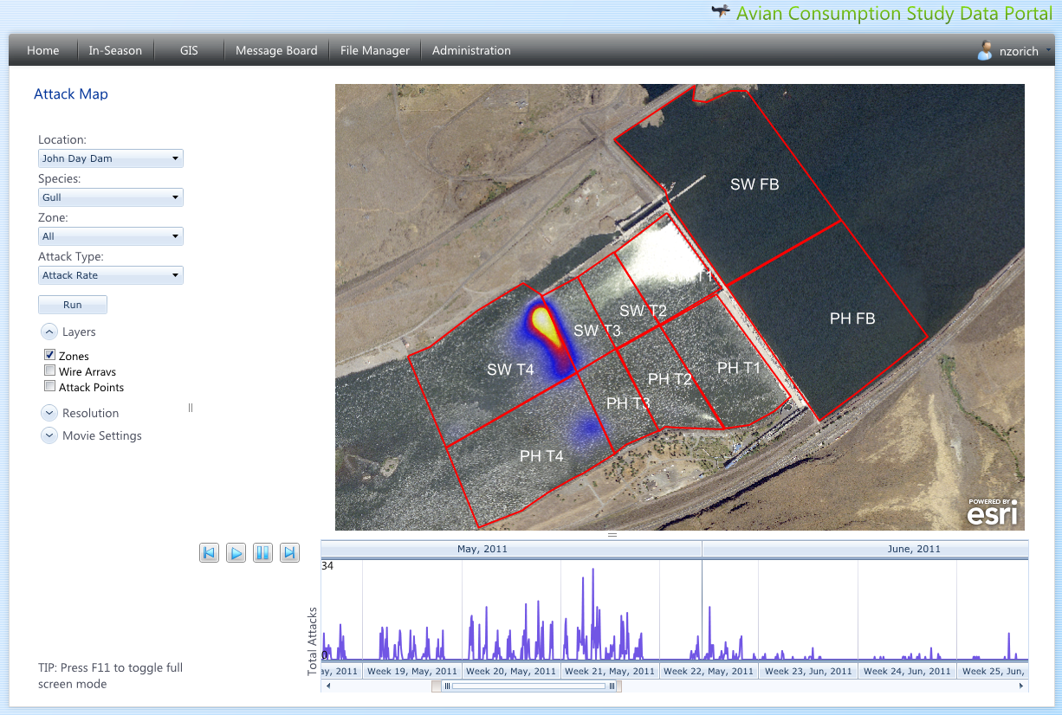
Figure 3. Heat map of gull attacks at John Day Dam showing where the bulk of the attacks (May and July 2011) happened.

At The Dalles, gulls were still focused on the area downstream of the avian lines (Figure 4) below the bridge with only a few below the ice/trash sluiceway. The number of attacks above the bridge is less than in 2010 when there was a gap in the avian lines there. Attacks & fish consumption spiked on July 21, 2011 when the hazing boat had to be taken in for maintenance.

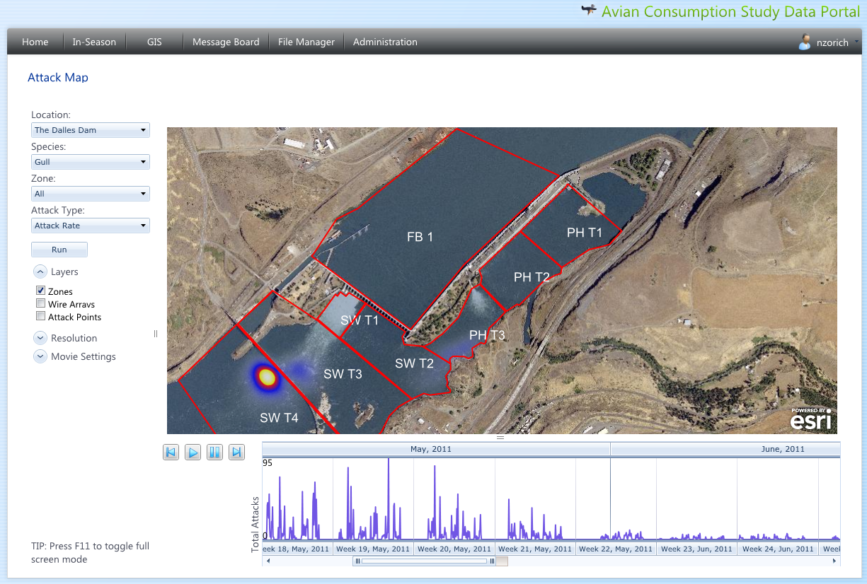
Figure 4. Heat map of gull attacks at The Dalles showing where the bulk of the attacks happened (May and June 2011).

Of note the smolt index for age-0 Chinook is at 2.6 million and was 2.2 million this time last year at this time, and in general was delayed but has declined. Water temp is at 20.3C 8/9/11 and is increasing. It was 19.0C on 8/9/10 and had already started decreasing (WQM data from DART). Concern for the delayed age-0 Chinook outmigration caused project biologist at The Dalles & John Day dams to extend the boat hazing contracts at both projects.

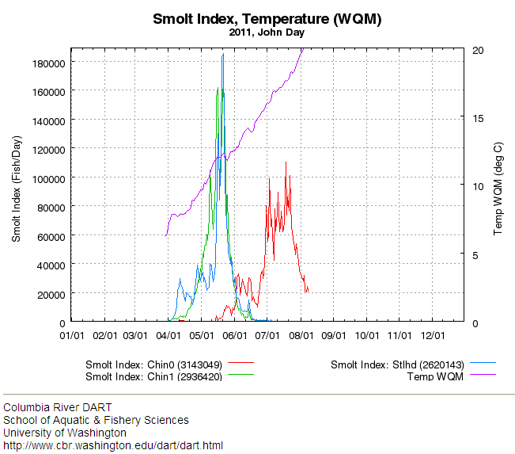
Figure 5. John Day smolt index and temperature taken from UW’s DART.

